**Problem Set 2**

**Research method Problem Set 2 due Mon 22th Oct, 17:00**

**LIU BOWEN (1004028)**

For Problem Set 1, I use the following packages:

|  |
| --- |
| import matplotlib.pyplot as plt  import numpy as np  import scipy as sp  import scipy.stats as ss  import scipy.stats as ss  import math |

**Problem 1**

Answer:

a)

Up to now, I have leant three different methods to calculate standard deviation or standard error, namely, analytical method, perturbation and Monte Carlo.

For the analytical approach, I need to calculation two partial derivation for this problem(r and Q). According to the previous equation, I can obtain the Equation 1.

$$t={In(\frac{Q*r}{P_{0}}+1)}/r$$

Equation 1

The code is as follow, the rDerivation() and qDerivation() calculate the partial derivation of r and Q. stdDeviat() firstly calculate the deviation and then sqrt() the result.

|  |
| --- |
| def rDerivation(Q, r, P0):  return ((Q*r) / (Q*r + P0) - np.log(Q*r/P0 + 1)) / r**2  def qDerivation(Q, r, P0):  return (1.0/r) * (1.0 / (Q*r/P0 + 1)) * (r/P0)  def stdDeviat(Q, r, dQ, dr, P0):  analytical_ans = rDerivation(Q, r, P0)**2 * dr**2 + qDerivation(Q, r, P0)**2 * dQ**2  return np.sqrt(analytical_ans) |

As absolute r is 0.2% therefore dr = 0.002, Q is 10% relative so dQ should be 1000*10%=100, and P0 = 5.

|  |
| --- |
| Q, r, dQ, dr, P0 = 1000, 0.027, 100, 0.002, 5  print 'Problem 1-a result:', stdDeviat(Q, r, dQ, dr, P0) |

The answer is shown in Figure 1:



Figure 1 Analytical standard deviation

b)

As for MC method, I need to define tFunc() to represent the function. Then, randomly generated Q and r each time.

|  |
| --- |
| def tFunc(Q, r, P0):  return (np.log((Q*r/P0)+1)) / r  def MC(Num):  t =[]  for sample in range(Num):  Q = ss.norm.rvs(1000, 100)  r = ss.norm.rvs(0.027, 0.002)  P0 = 5.0  t.append(tFunc(Q, r, P0))  stdDeviat = np.std(t, ddof=1)  return stdDeviat  Num = 1000000  print MC(Num) |

When I input Num = 106 the standard deviation is shown in Figure 2:

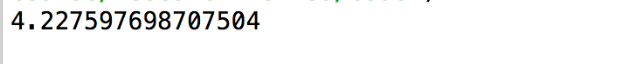

Figure 2 MC method

**Problem 2**

Before Monte-Carlo, I firstly need linear fit to calculate the intercept, C. From the equation, I regard the Ea and C as the gradient and intercept therefore I define xValue() and yValue() to calculate each value of x and value of y respectively. The origin data comes from the table with the number of eight pair. After that, I leverage the numpy.polyfit() function. This function fits a polynomial p(x) = p[0] * x**deg + ... + p[deg] of degree *deg* to points (x, y) and return values are the polynomial coefficients, and highest power first. In fact, there are many other ways to fit, such as scipy.stats.linregress()

|  |
| --- |
| kb = 8.6173303e-5  def xValue(Tc):  return (-1 / (kb * Tc))  def yValue(phi, Tc):  return np.log(phi / Tc**2)  def calculateC(Tc_array, pfi_array):  x_value = []  y_value = []  for i in range(len(Tc_array)):  x_value.append(xValue(Tc_array[i]))  y_value.append(yValue(pfi_array[i], Tc_array[i]))  gradient, C = np.polyfit(x_value, y_value, 1)  x_mean = np.mean(x_value)  y_mean = np.mean(y_value)  return C, x_mean, y_mean  Tc_array = [440.6, 440.3, 439.7, 438.2, 437.3, 434.4, 431.7, 429.7];  pfi_array = [4.5, 3.4, 3.2, 2.7, 2.1, 1.0, 0.8, 0.5]  C, x_mean, y_mean = calculateC(Tc_array, pfi_array)  print 'The intercept C:', C |

The value of C is shown in Figure 3:



Figure 3 The value of intercept C

a)

When I solve it by Monte Carlo algorithem, I firsly need to calculate the mean of Tc and pfi. There are two ways to get mean of Tc and pfi. One is calculate the mean from Tc_array[] and pfi_array[]. The other is calculate the mean from the eight-pair data from xValue() and yValue() then calculate the mean of Tc and pfi. Shown in code below, as xValue equals (-1 / (kb * Tc)) therefore mean of Tc can be done by (-1 / (x_mean*kb)) where x_mean is the 8 data from xValue(). After that, the mean of Tc and pfi is shown in Figure 4.

|  |
| --- |
| def Ea(Tc, pfi, C):  return kb * Tc * (C - np.log(pfi / np.square(Tc)))  meanTc = -1 / (x_mean*kb)  meanpfi = math.exp(y_mean)* meanTc**2  print 'The Tc mean:', meanTc  print 'The pfi mean:', meanpfi  stdDeviatTc = 0.2  stdDeviatpfi = 0.1  num = 10000  Ea_value = []  def MCEa(Tc, stdTc, phi, stdphi, C, N_experiments):  for i in range(N_experiments):  Tc_random = ss.norm.rvs(Tc, stdTc)  phi_random = ss.norm.rvs(phi, stdphi)  Ea_value.append(Ea(Tc_random, phi_random, C))  mean = np.mean(Ea_value)  stdDeviat = np.std(Ea_value)  stdError = stdDeviat / math.sqrt(N_experiments)  return mean, stdDeviat, stdError |

The mean of Tc and pfi is as below:

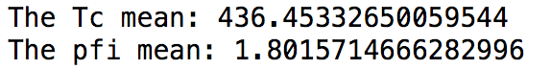

Figure 4 Mean of Tc and pfi

b)

|  |
| --- |
| mean, stdDeviat, stdError = MCEa(meanTc, stdDeviatTc, meanpfi, stdDeviatpfi, C, num)  print 'The Ea mean:', mean  print 'The Ea standard deviation:', stdDeviat  print 'The Ea standard error:', stdError  num_bins = 100  plt.hist(Ea_value, num_bins, facecolor='red', edgecolor='black') |

Continue the code, the histogram of 10000 simulations is shown in Figure 5.

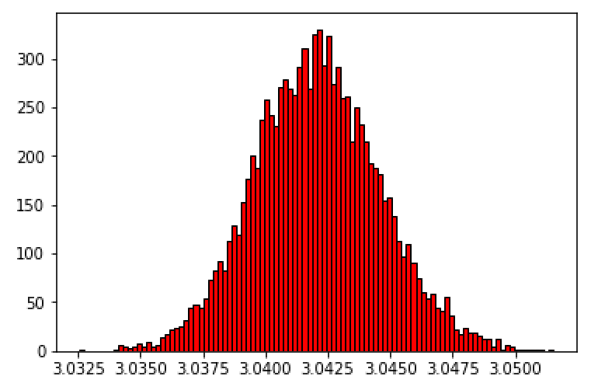

Figure 5. Histogram of 10000 simulations

c) and d)

The Figure 6 shows the result of standard deviation and standard error. Noted that the sample size is 10000 therefore the standard error = standard deviation / sqrt(10000).

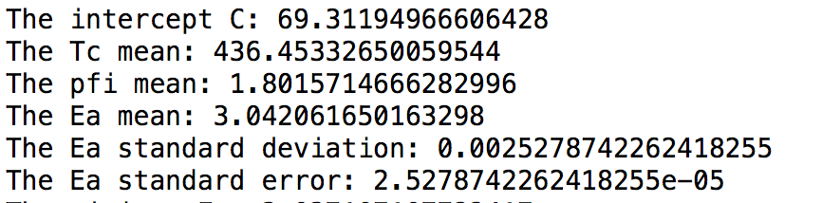

Figure 6. Standard deviation and Standard error

e)

I calculate the min and max of Ea by two-tails confidence interval. Use norm.ppf() to obtain the value for probability = (1-0.95)/2.

|  |
| --- |
| def EaBounds(meanEa, stdDeviaEa, confidence):  z = ss.norm.ppf((1+confidence)/2)  minEa = meanEa - stdDeviaEa * z  maxEa = meanEa + stdDeviaEa * z  return minEa, maxEa  minEa, maxEa = EaBounds(mean, stdDeviat, 0.95)  print 'The minimum Ea:', minEa  print 'The maximal Ea:', maxEa |

The code is as above and the min and max value are shown in Figure 7.



Figure 7. The min and max Ea